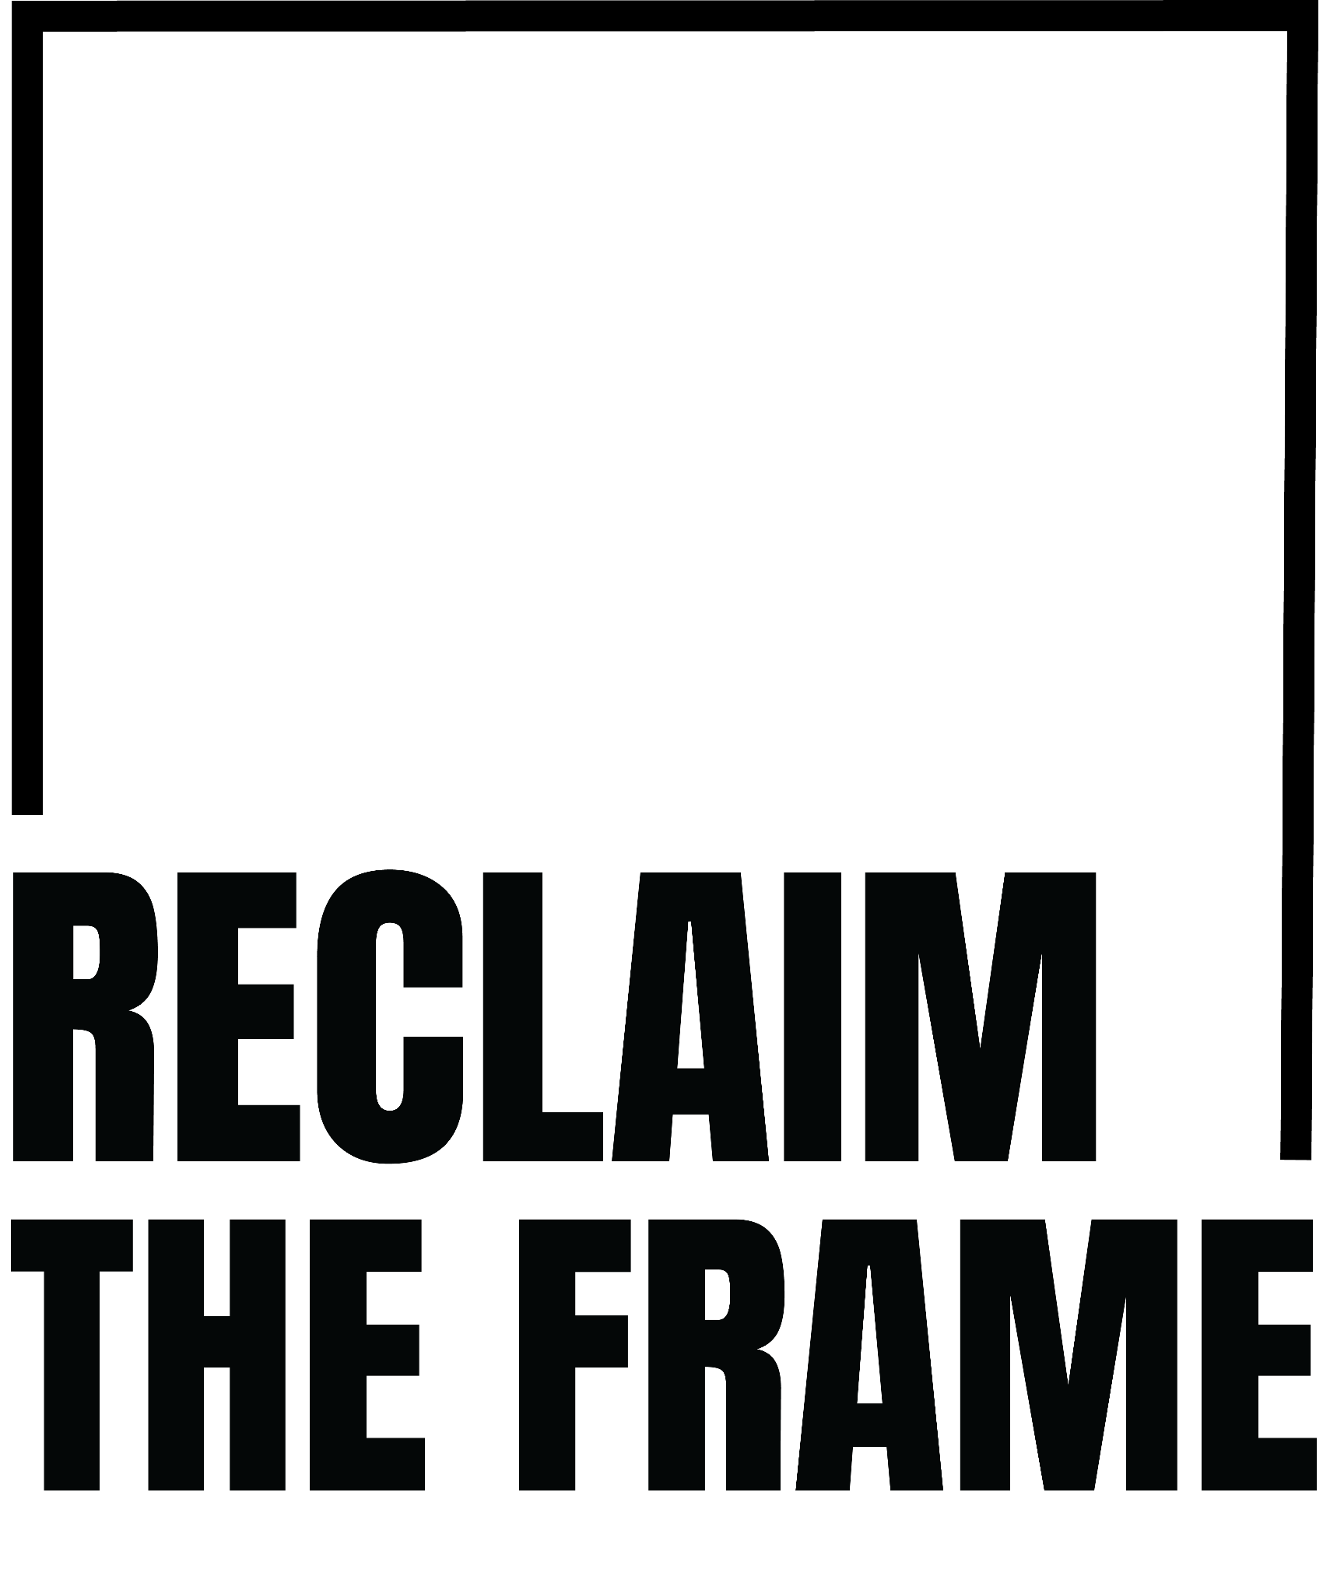

OPERATIONS & PROGRAMMES COORDINATOR

Accessible Recruitment Pack
Application deadline: Wednesday 29 July 2026, 9.00am

ROLE SUMMARY
Salary: £30,000 per annum full-time equivalent (£24,000 pro rata)
Hours: Four days per week (Monday-Thursday)
Contract: Fixed term until 31 March 2027 (continuation subject to funding and organisational review)
Location: Hybrid. Applicants should be based within commuting distance of London, with regular attendance at our Brixton office, Soho workspace and London events.
Reports to: Director
Probation: Two months
Expected start date: Week commencing 24 August 2026 or as soon as possible
Applicants must have the right to work in the UK at the time of appointment.

ABOUT RECLAIM THE FRAME
Founded in 2003, Reclaim The Frame (formerly Birds' Eye View Film Festival) is the UK's leading charity for gender equity in cinema.
We champion women and filmmakers of all marginalised genders through training, mentoring, advocacy and audience engagement, helping to build more equitable, inclusive and sustainable careers and a fairer film culture.
Working across the UK and internationally, we deliver industry-leading talent development programmes, support independent film releases, convene conversations across the screen sector, and advocate for systemic change throughout the screen industries.
As a small charity with national and international reach, we work collaboratively with filmmakers, cinemas, distributors, funders and industry partners to create lasting change. Every member of our team plays an important role in delivering that mission.

THE OPPORTUNITY
We're looking for an exceptional organiser to join Reclaim The Frame as our new Operations & Programmes Coordinator.
This is a pivotal role within our small charity, providing the organisation, coordination and day-to-day administration that underpins our work. Working closely with the Director, Programme Producers and Finance Officer, you'll help ensure our programmes and projects are delivered professionally, efficiently and with care.
This role is ideal for someone who enjoys creating order, communicating clearly and working across a wide range of projects. You'll be a key point of contact for programme participants and partners, coordinate practical delivery across our activities, maintain organisational systems and help keep everything running smoothly.

KEY RESPONSIBILITIES

Programmes & Projects
- Coordinate the administration of Reclaim The Frame's training, talent development and other programmes.
- Work closely with Programme Producers to support the smooth delivery of programme activity.
- Act as a key point of contact for programme participants, speakers and contributors.
- Coordinate practical arrangements for sessions, labs, screenings and events.
- Maintain programme records, databases, trackers and shared documentation.
- Support monitoring and evaluation through surveys and record keeping.

Operations & Administration
- Support the day-to-day running of Reclaim The Frame.
- Maintain filing systems, shared drives, calendars, databases and organisational records.
- Support organisational administration and confidential documentation.
- Coordinate the onboarding and day-to-day support of interns.
- Support the Director with diary management and travel arrangements.

Communications & Digital
- Maintain and update the Reclaim The Frame website.
- Upload and schedule approved newsletter and social media content.
- Maintain organisational platforms including Google Workspace, Slack, Zoom, Mailchimp, Canva and other digital systems.
- Monitor the shared inbox and direct enquiries appropriately.

Events & Delivery
- Support screenings, industry events, programme labs and networking activity.
- Coordinate venues, catering, technology and access requirements.
- Attend events where required, including occasional evenings (time off in lieu provided).

PERSON SPECIFICATION

Essential
We're looking for an exceptional organiser.
You will be able to demonstrate:
- Experience in an administration, coordination or operations role.
- Experience supporting projects, programmes or events.
- Excellent organisational skills and strong attention to detail.
- Experience maintaining accurate records, systems and documentation.
- Excellent written and verbal communication skills.
- Confidence communicating professionally with a wide range of people.
- The ability to prioritise competing tasks and remain calm under pressure.
- Confidence using digital tools and the ability to learn new systems quickly.
- The ability to work independently while contributing positively to a small, collaborative team.
- Professionalism and discretion when handling confidential information.
- A genuine interest in film, the creative industries and Reclaim The Frame's mission.

Desirable
It would be helpful if you also have experience of:
- Working in film, television, media, arts, culture or the charity sector.
- Supporting training, mentoring or professional development programmes.
We recognise that people develop skills through many different routes. If your experience doesn't match every point above but you believe you would be a strong fit for the role, we'd still love to hear from you.

WORKING AT RECLAIM THE FRAME
Reclaim The Frame is a values-led charity guided by care, compassion and integrity.
We strive to create an inclusive workplace where everyone can contribute, develop and bring their whole selves to work. We value different perspectives and lived experiences, encourage learning and reflection, and support one another with openness and respect.
In return we offer:
- A supportive, collaborative and flexible working environment.
- Hybrid working.
- 33 days annual leave (including bank holidays), pro rata.
- Workplace pension through NEST, with employer contributions of 3% of qualifying earnings.
- Access to screenings, festivals, industry events and networking opportunities.
- Opportunities to build relationships across the UK film sector through our programmes and partnerships.

EQUALITY, DIVERSITY & ACCESS
At Reclaim The Frame, we believe our work is strengthened by a team with a broad range of experiences, backgrounds and perspectives.
As an equal opportunities employer, we actively encourage applications from people currently underrepresented across the film and cultural sectors, including people who experience racism, misogynoir, transphobia, ableism and class-based discrimination.
We're committed to making our recruitment process as accessible as possible. Applications and responses to the application questions are welcome in written, audio or video formats. If you require adjustments at any stage of the recruitment process, or would like to discuss access requirements before applying, please contact us.
We are committed to making reasonable workplace adjustments for disabled staff and those with long-term health conditions.
Reclaim The Frame is a London Living Wage Employer, a Disability Confident Employer and upholds the BFI Diversity Standards.

HOW TO APPLY
Complete the online application form: click here
You will be asked to upload:
- Your CV.
- Either a supporting statement (maximum one A4 page) or an audio/video submission (maximum four minutes).
You will also be asked to answer four short application questions covering:
- Your interest in Reclaim The Frame and our mission.
- Your experience coordinating programmes, projects or events.
- Your experience using digital systems and tools.
- Your approach to professional communication and supporting participants and collaborators.
Applications close at 9.00am on Wednesday 29 July 2026.
Applicants must have the right to work in the UK at the time of appointment.

CONTACT
Email: mail@reclaimtheframe.org
Website: https://reclaimtheframe.org
Newsletter: https://reclaimtheframe.org/join-our-mailing-list
Instagram: @reclaimtheframe
If you have any questions about the role or would like to discuss access requirements before applying, please get in touch.
